**SIT103/SIT772: Database Fundamentals**

**4.1P: Normalisation**

Q1

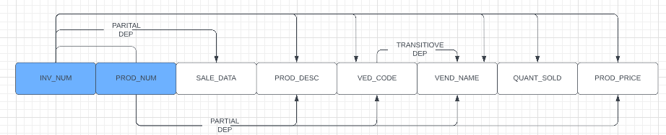

Q2

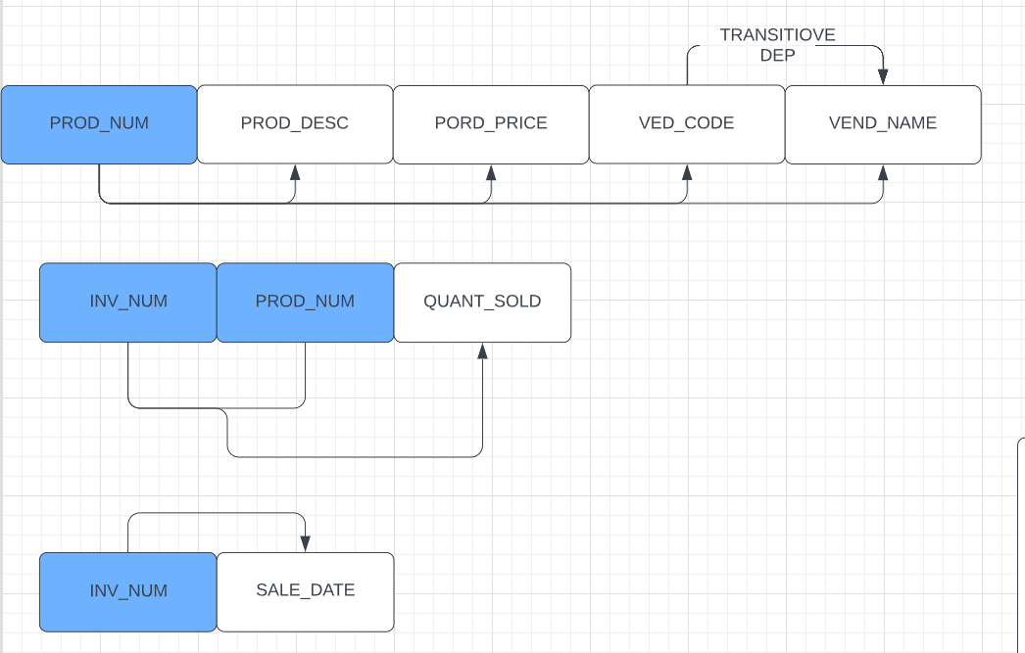

Q3

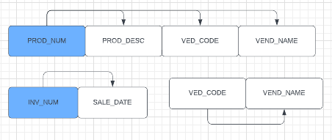

Q4

The invoice table satisfies the condition of 1NF because INV_NUM and PROD_NUM are used as PK and each record has a unique value and the duplicate group has been removed.

The (PROD_NUM, PROD_DESCRIPTION, VEND_CODE, VEND_NAME, PROD_PRICE) satisfies the conditions of 2NF, which satisfies 2NF because it satisfies 1NF and there are no more partial dependencies, but still have transitive dependencies.

The (INV_NUM, PROD_NUM, QUANT_SOLD)

(INV_NUM, SALE_DATE)

(VEND_CODE, VEND_NAME)

(PROD_NUM, PROD_DESCRIPTION, VEND_CODE, PROD_PRICE)

Are 3NFsatisfies the 3NF condition because its primary key (PK) is not part of either of the 1NF and 2NF primary keys.

Q5

